Project Scope: Customer Analytics in Retail Phase 3 and 4

Objectives:

  - Analyze sales performance-Overall and By Products
  - Study customer buying behavior and create customer segments
  - Develop Campaign Response Model –Use traditional and ML algorithms
  - Perform Sentiment Analysis of Customer Feedback
  - Develop Web Application/Dashboard

GitHub repository:
https://github.com/emmanuelogbonna/AIML-Retail-Campaign-Project
The repository contains the project notebook, README, and supporting project files.
Contents
Phase 1 is all about data management 1
Phase 2 is about data analysis using graphs, tables etc (EDA) 12
Phase 3 is about developing a model using Binary Logistic Regression(using final master data) 19
Phase 4 is about using ML methods and compare with Binary Logistic Regression 25

Phase 1 is all about data management

- Understand two data sets: 1) Transaction Data- Year 2023 2) Campaign Data-Jan 2024
(understand variables, data dimension, unexpected values (ex: negative values in quantity), Check duplicate records if any etc.)
Understanding the variables
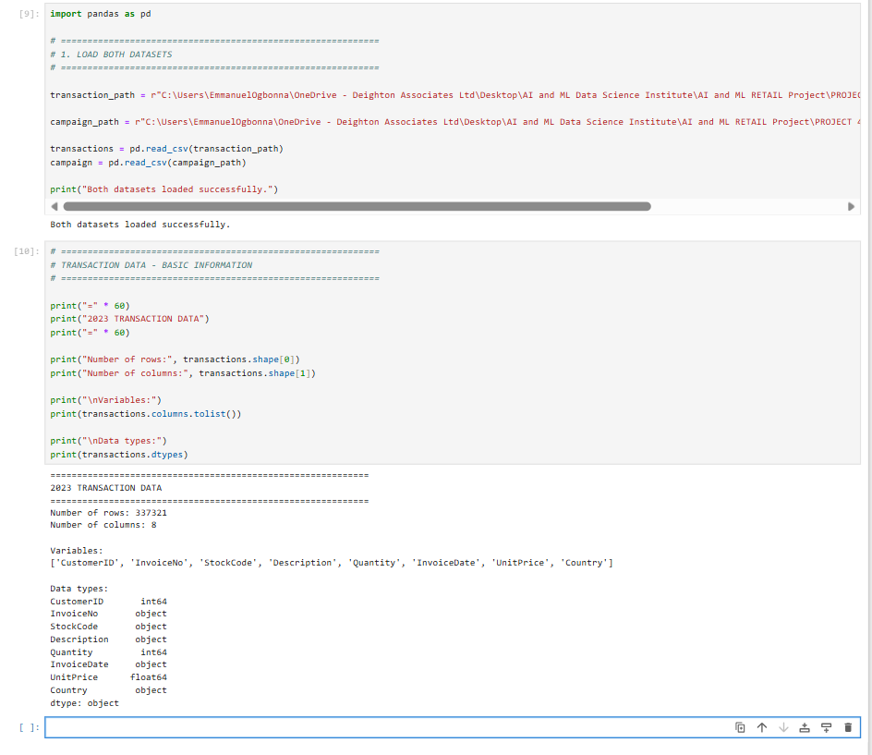
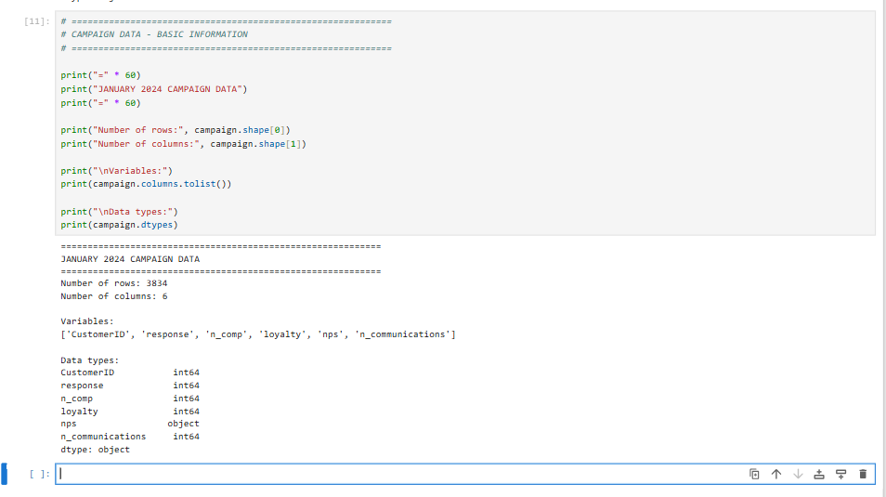
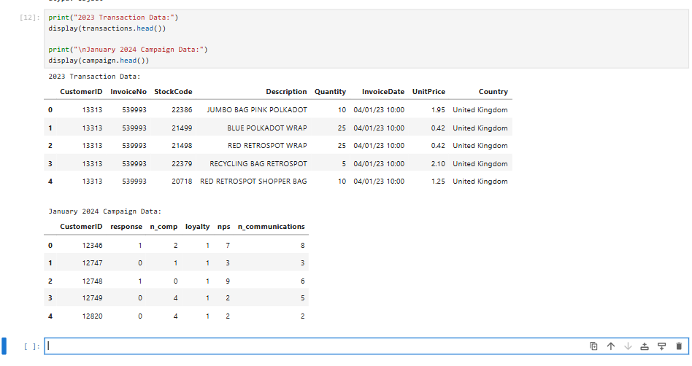
Duplicate records
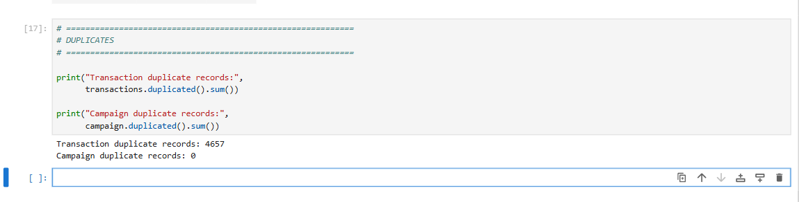
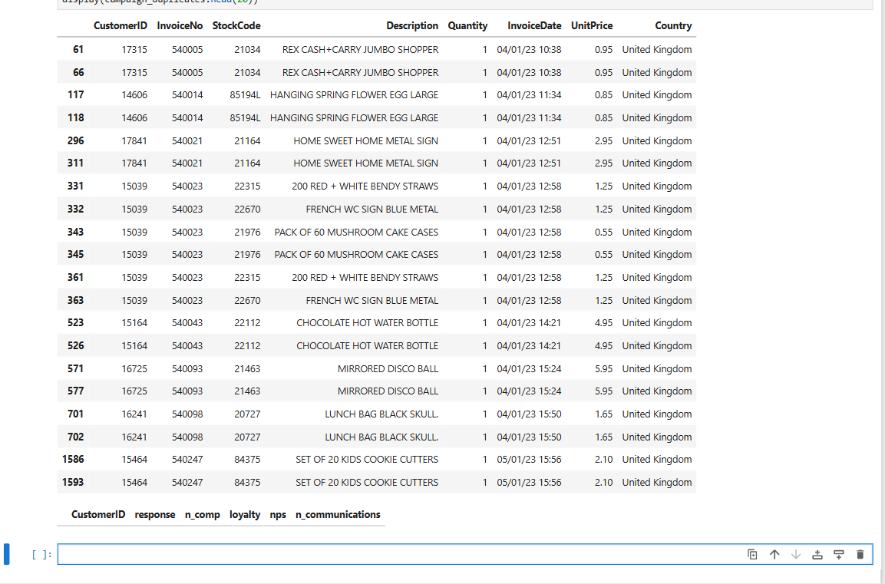
Checking the Negative Quantity values.
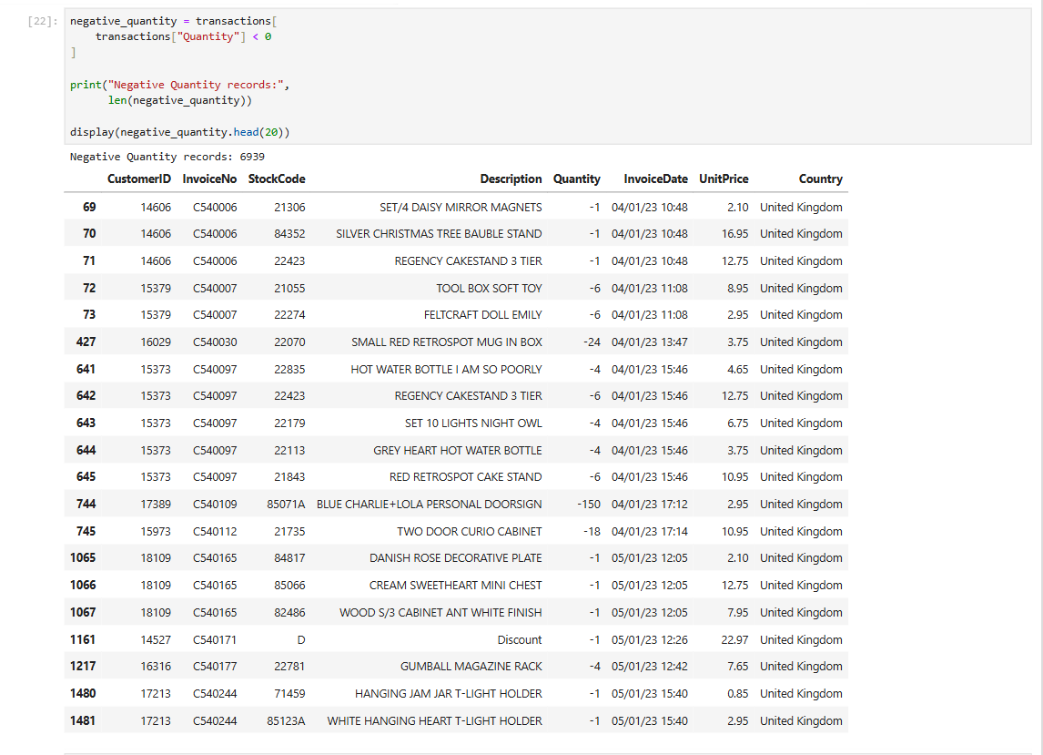

Checking the variables such as Response, Loyalty, and NPS
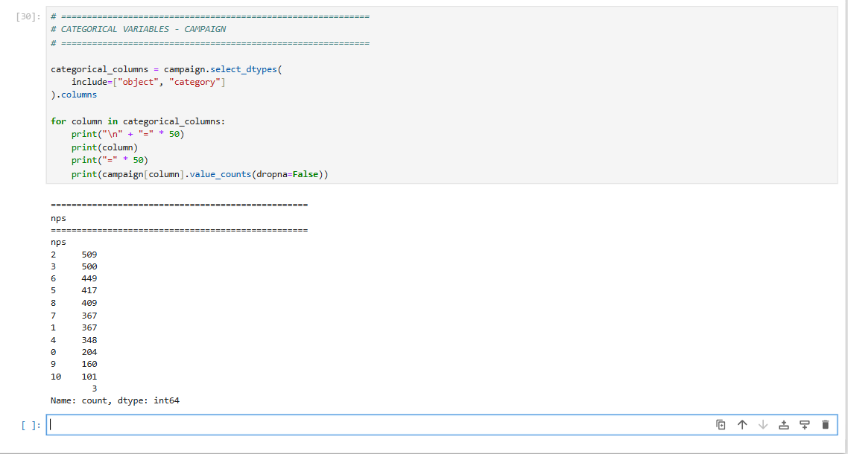
Response
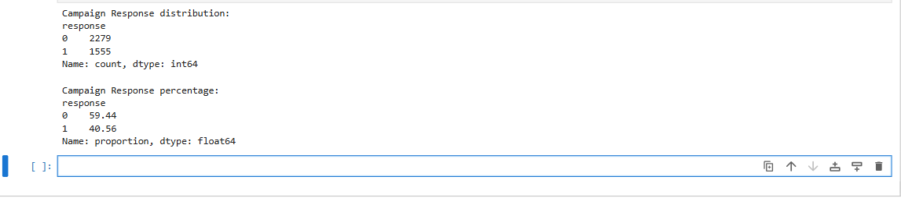
Nps
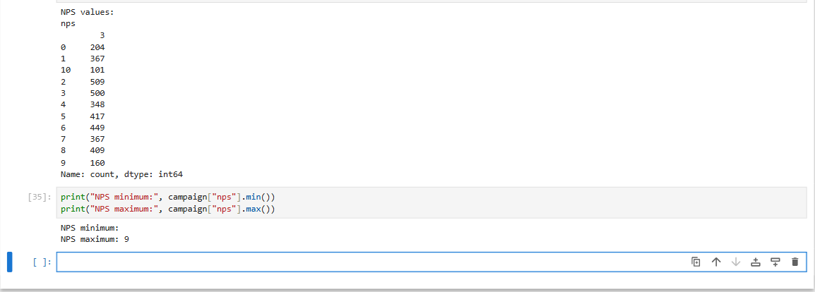
Summary
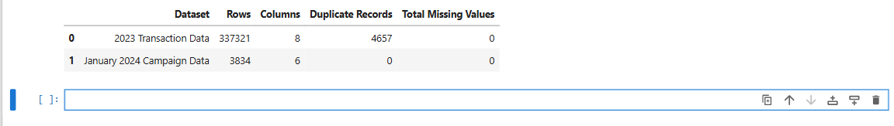

- Derive total sales for each customer (feature 1)
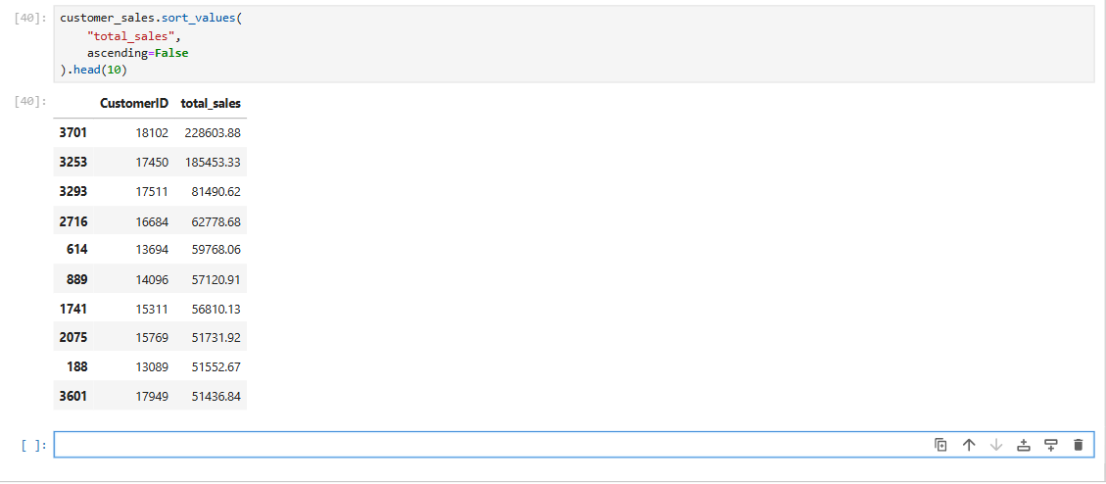

- Derive number of unique products purchased by each customer (feature 2)
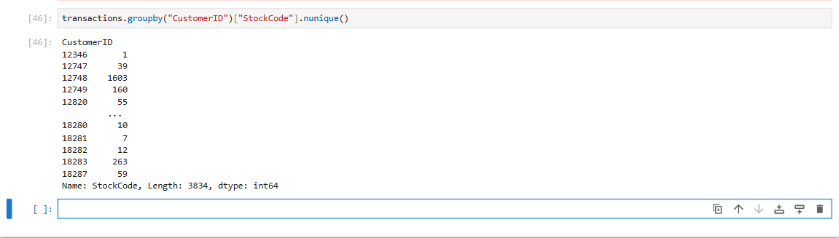

- Derive number of invoices generated by each customer (feature 3)/Or Number of days purchased

Number of Invoices created by each customer
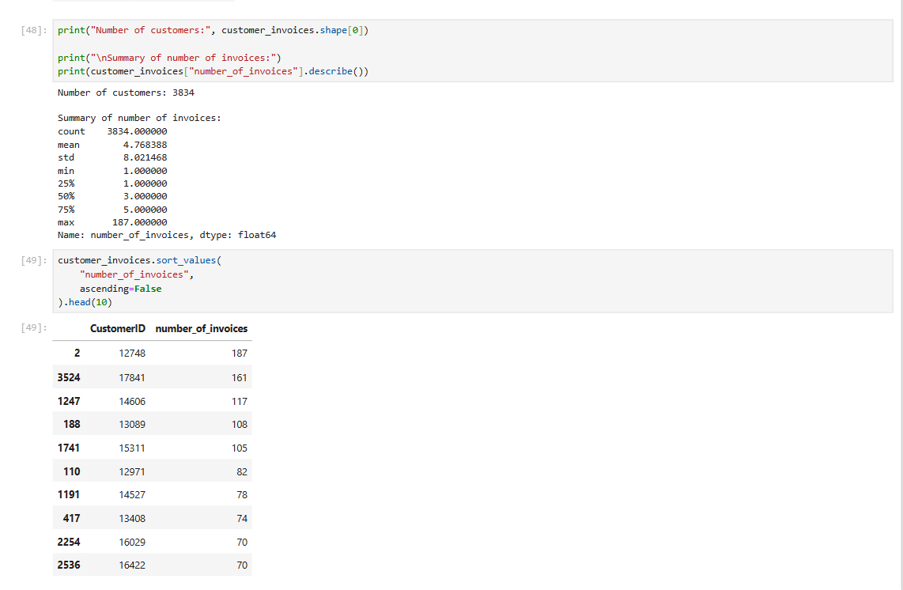
Additional features Total Sales, Number of Invoices, Purchase Days, average_invoice_value, average_quantity_per_invoice, average_product_price customer_lifetime_days.
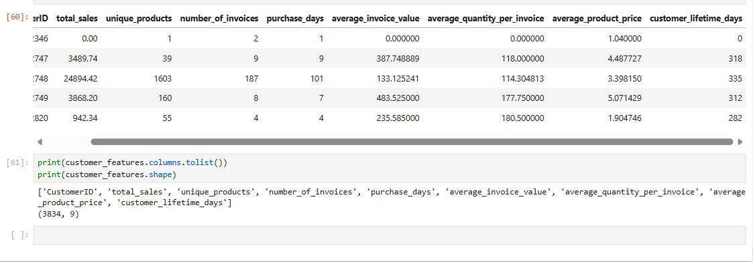

- Merge new features with campaign response data -Create a master data for campaign response model
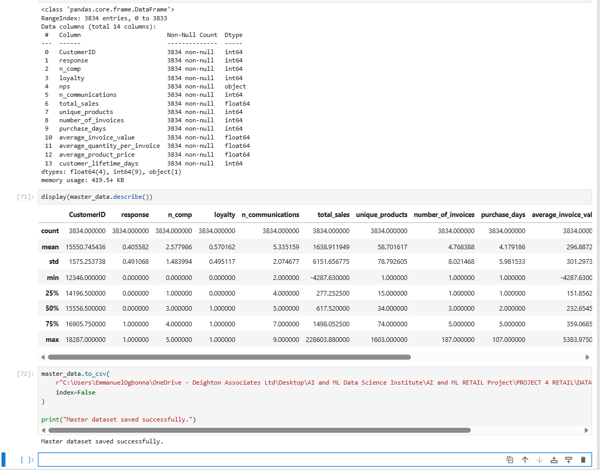

- Check each numerical variable for possible recoding into categorical variable (commonly done in modeling)
Full Distribution list
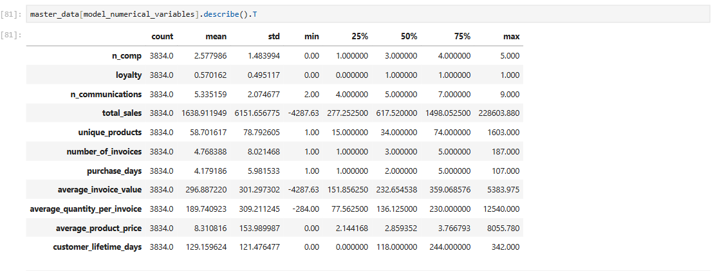
The Unique Values
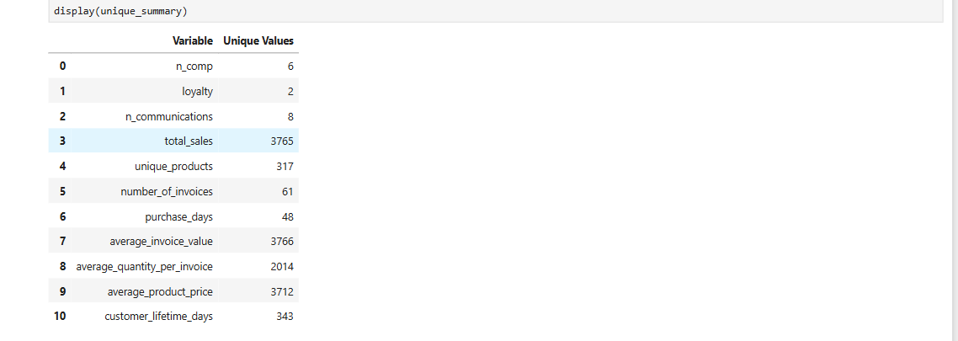
Loyalty Variable
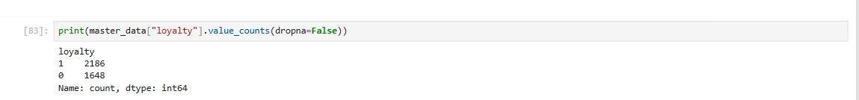
NPS
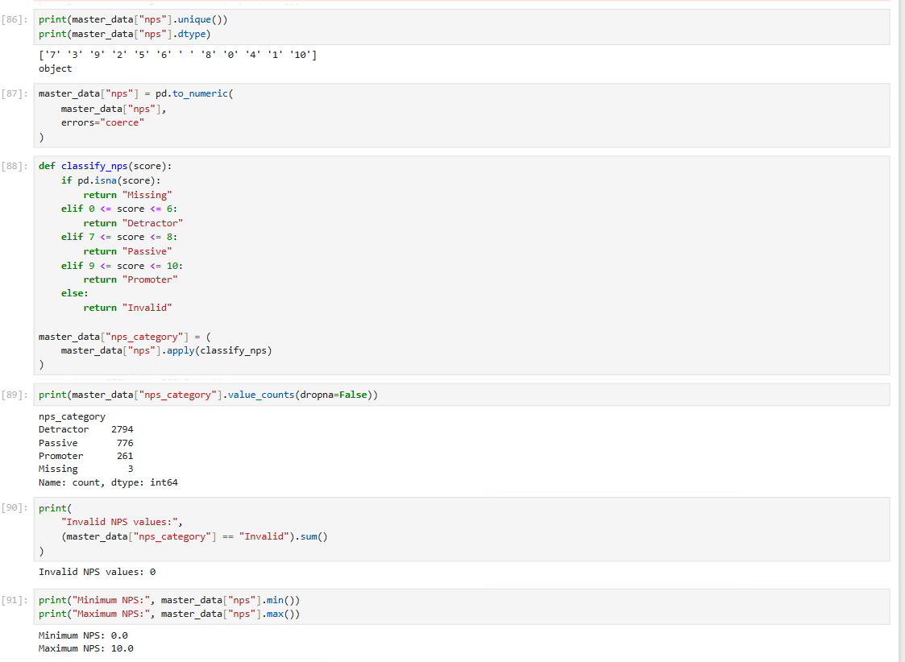

N Comp displaying the number of campaign and contracts
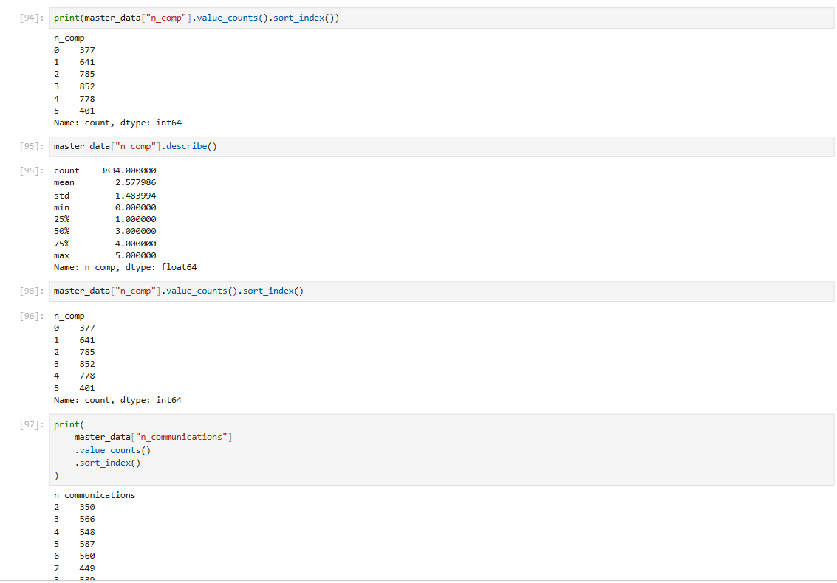

- Obtain overall campaign response rate
The overall campaign response rate is 40.56%.
Out of 3,834 customers targeted by the campaign, 1,555 customers responded and 2,279 did not respond.
The overall campaign response rate was therefore 40.56%, with a non-response rate of 59.44%.

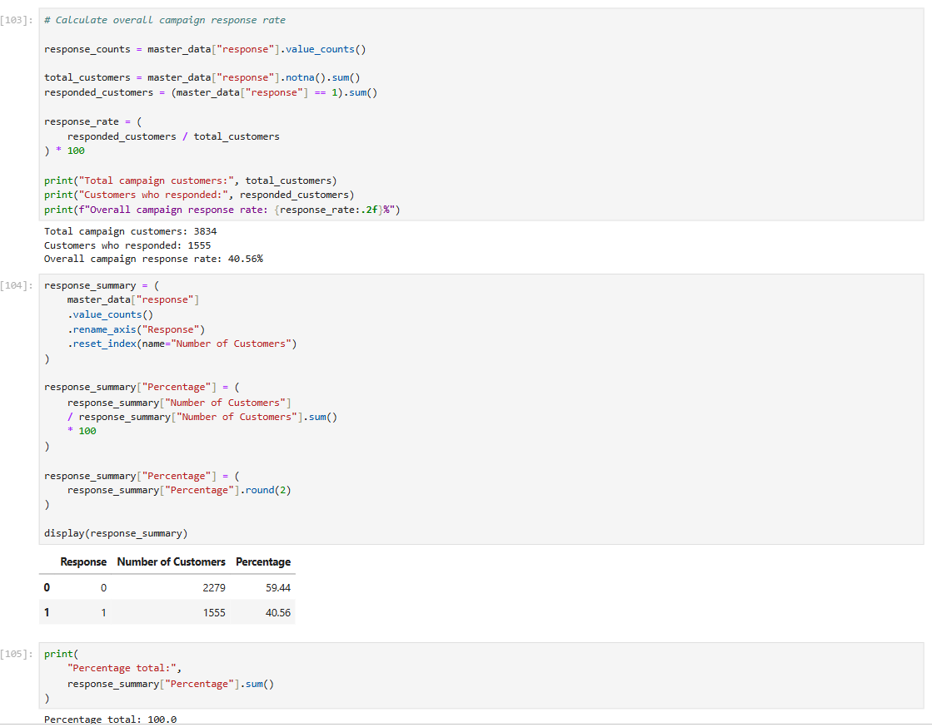

Phase 2 is about data analysis using graphs, tables etc (EDA)

The objective of phase 2 is to relate “Response” with other variables in the data. These insights will be useful prior to modeling in which you will take all variables together and model “Response” in phase 3
In addition, transaction data can be analysed to identify trend in month on month sales and find top products.

- Box-Whisker plot for variable NPS by “Response”.

This can be done for n_comp and n_communications.
NPS Campaign Response
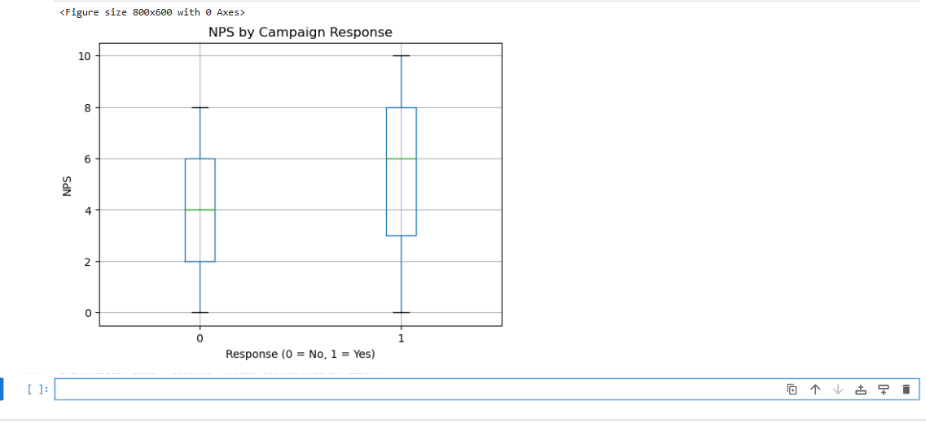
N_Comp Campaign Response
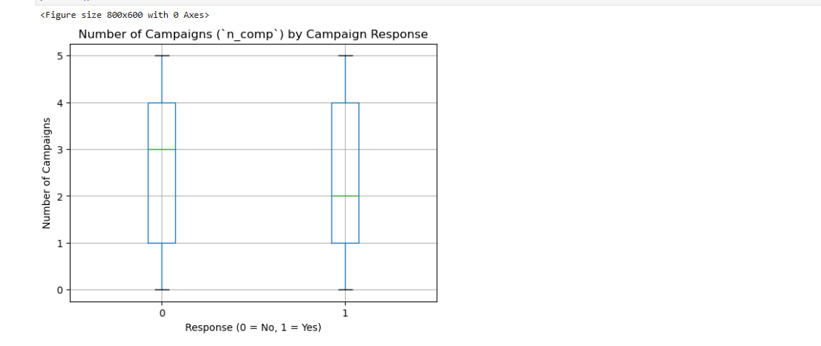

Communications by Campaign Response
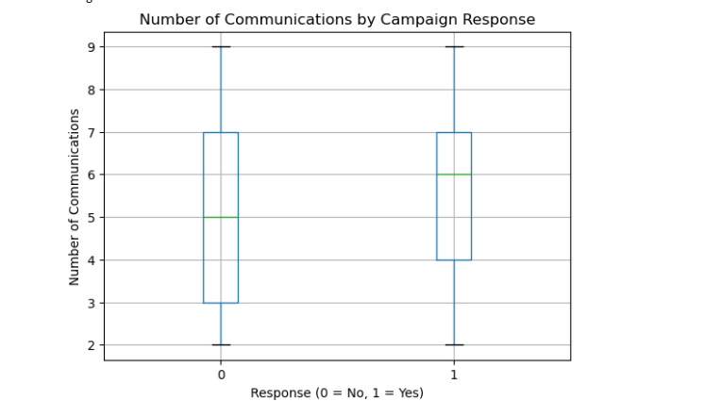
The statistical numbers behind the boxplot Median and Mean summary
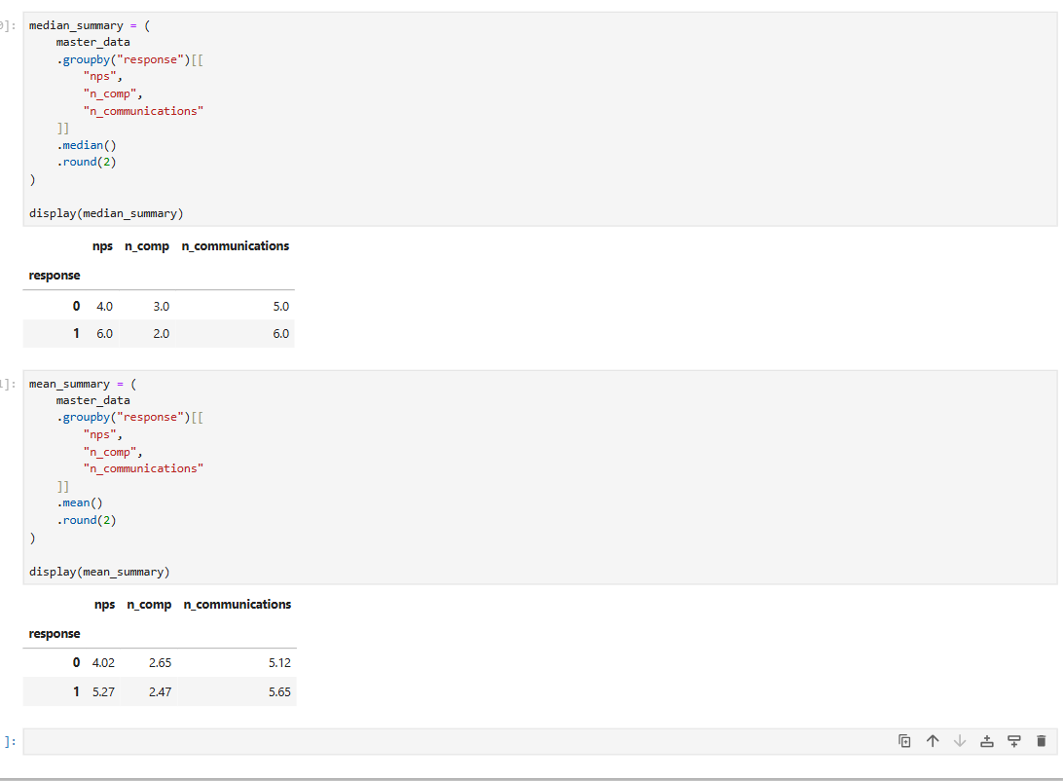

Summary
The box-whisker analysis indicates that NPS has the clearest difference between responders and non-responders.
Responders have substantially higher median NPS 6 against 4 and higher mean NPS 5.27 against 4.02.
N_Communications also shows a modest positive association with response, with responders having a median of 6 communications compared with 5 for non-responders.
In contrast n_comp shows very little difference with responders having a slightly lower mean and median number of previous campaigns.

- Table of Response Rate:

Loyalty | N | N+ | RR=(N+/N)*100
0 | 700 | 325
1 | 528 | 188

Same can be done for 3 categories of NPS- Detractor (0-6),Passive(7-8) And Promoter(9-10)
NPS Catergory
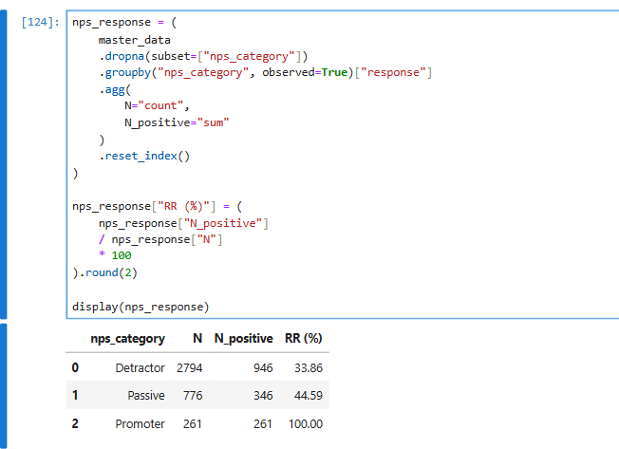
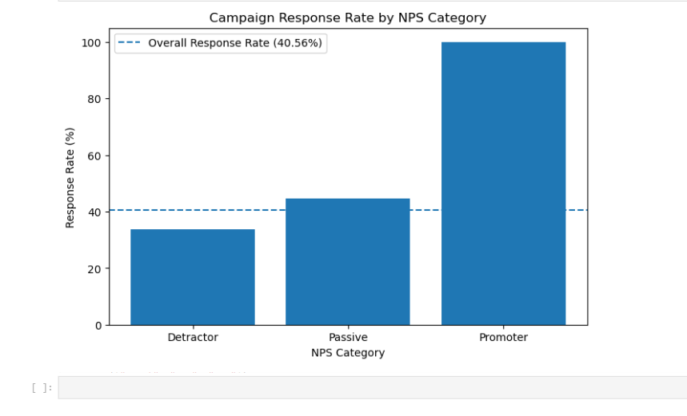
Individual NPS score (0-10) where the 100% Promoter response rate is from
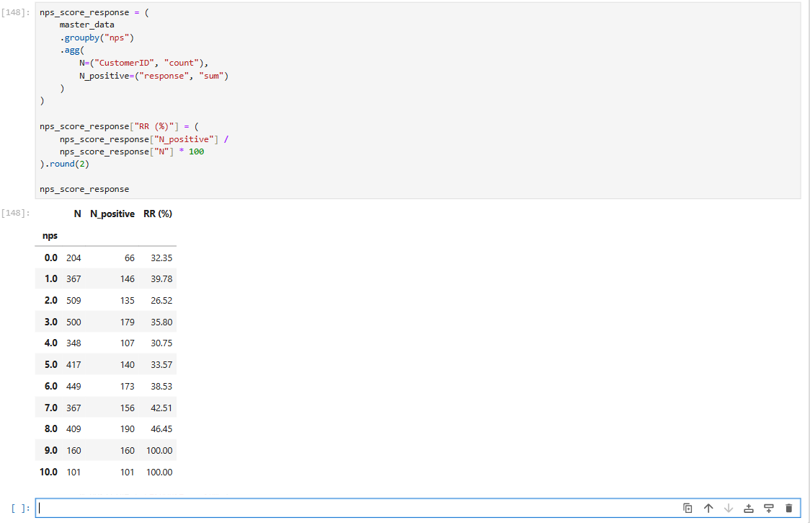
100% Promoter response rate is driven by the NPS scores 9 and 10.
Every customer with NPS = 9, 160/160 responded and Every customer with NPS =10, 101/101 responded. This indicates the potential response bias, where highly satisfied customers disproportionately represented among campaign respondents.

- Bar Chart:

Mean or median for feature1/2/3 for response=0 and 1
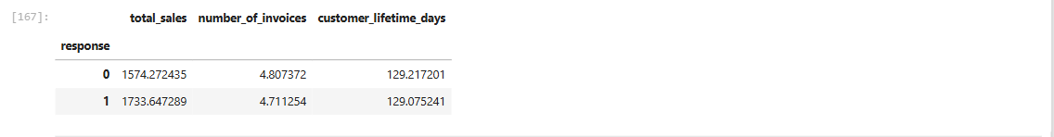
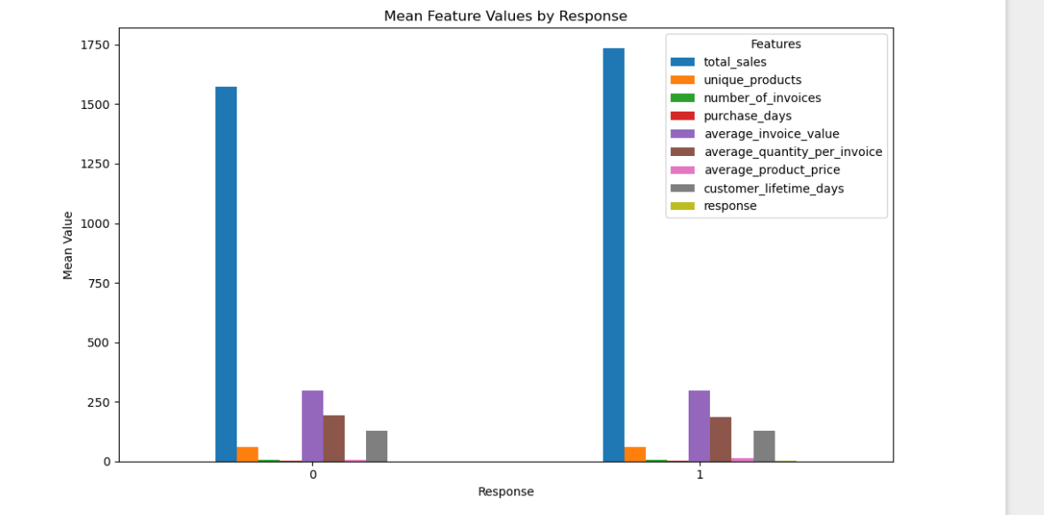

Then obtain Bar Chart.( X axis will have response 0 and 1)
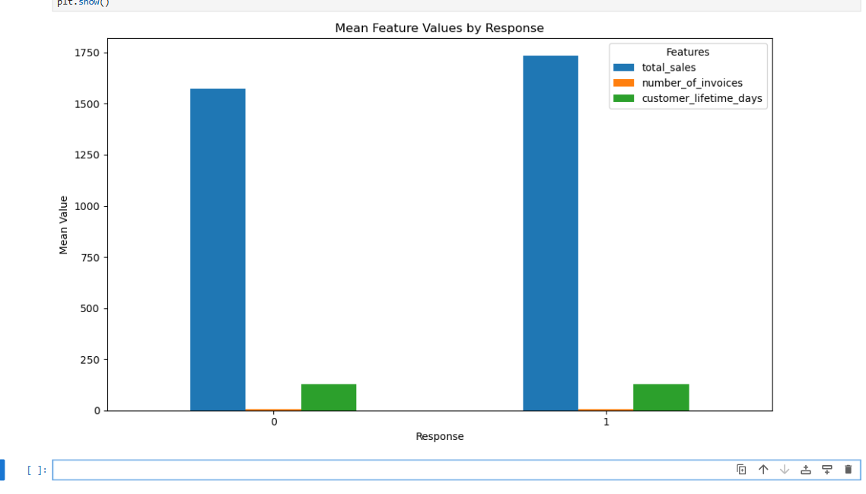

Note: Students can think of different types of tables and graphs for EDA

Bar Chart: Mean or median for feature1/2/3 for response = 0 and 1.
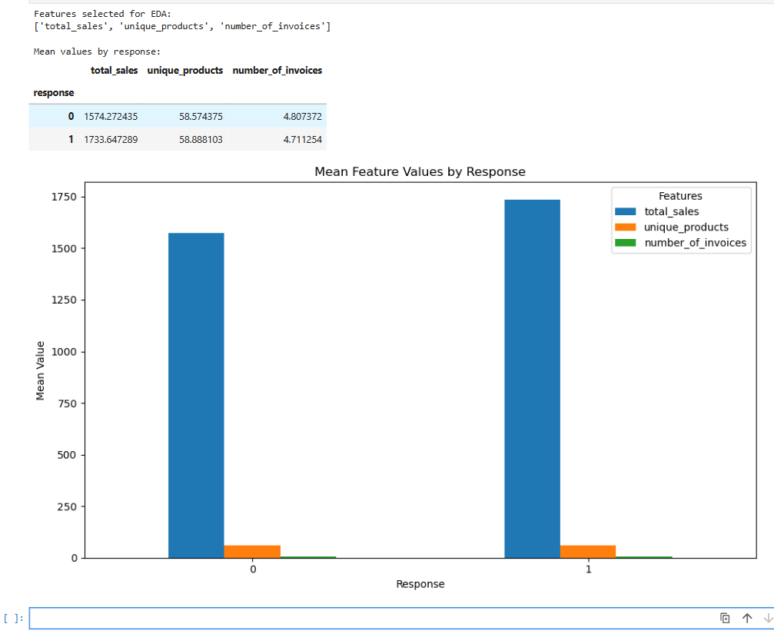

Response-rate charts for Campaign response
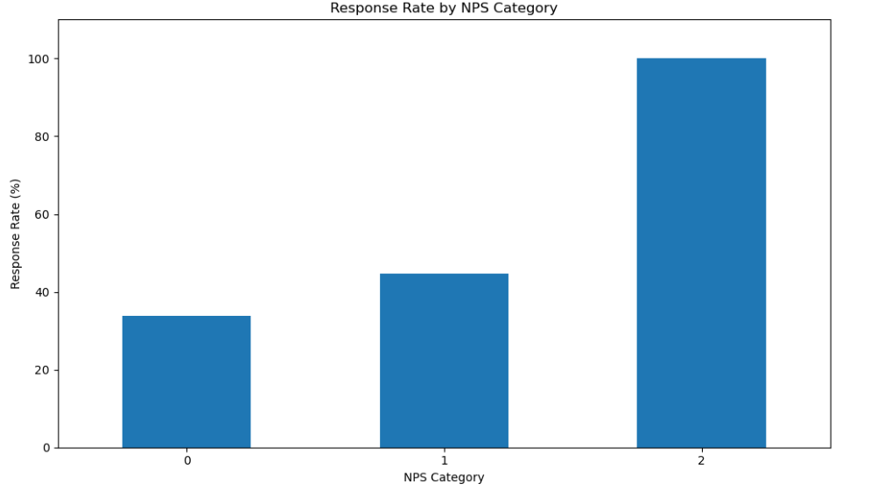

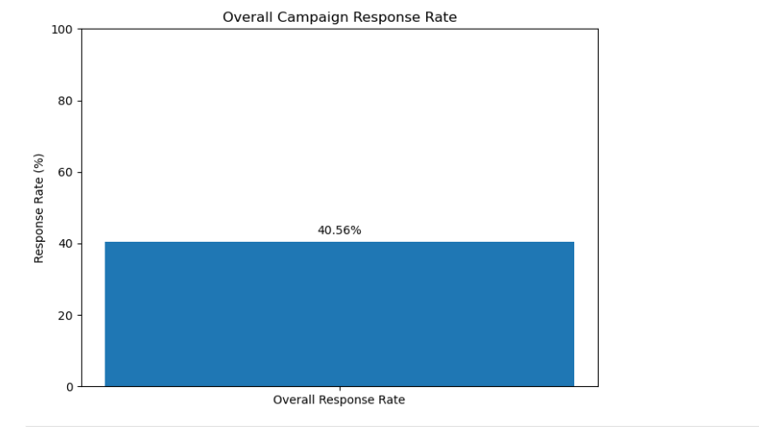
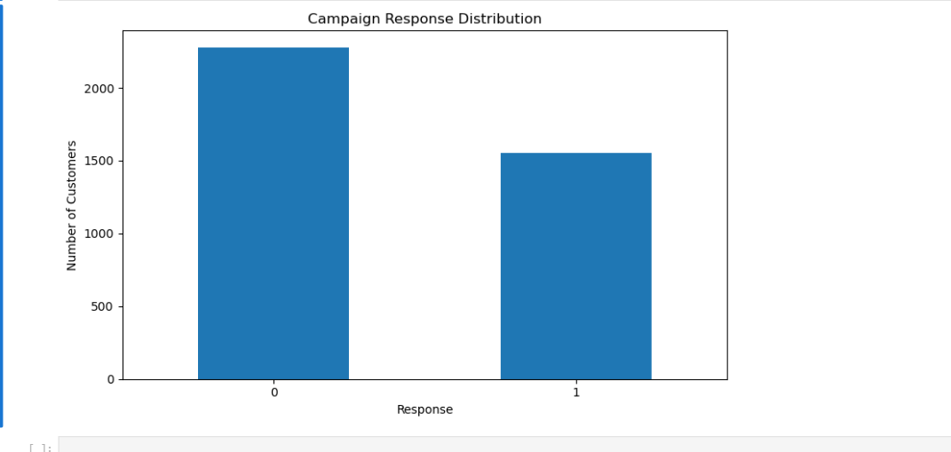

Phase 3 is about developing a model using Binary Logistic Regression(using final master data)

- Create data partition into train and test data sets ( 80/20)
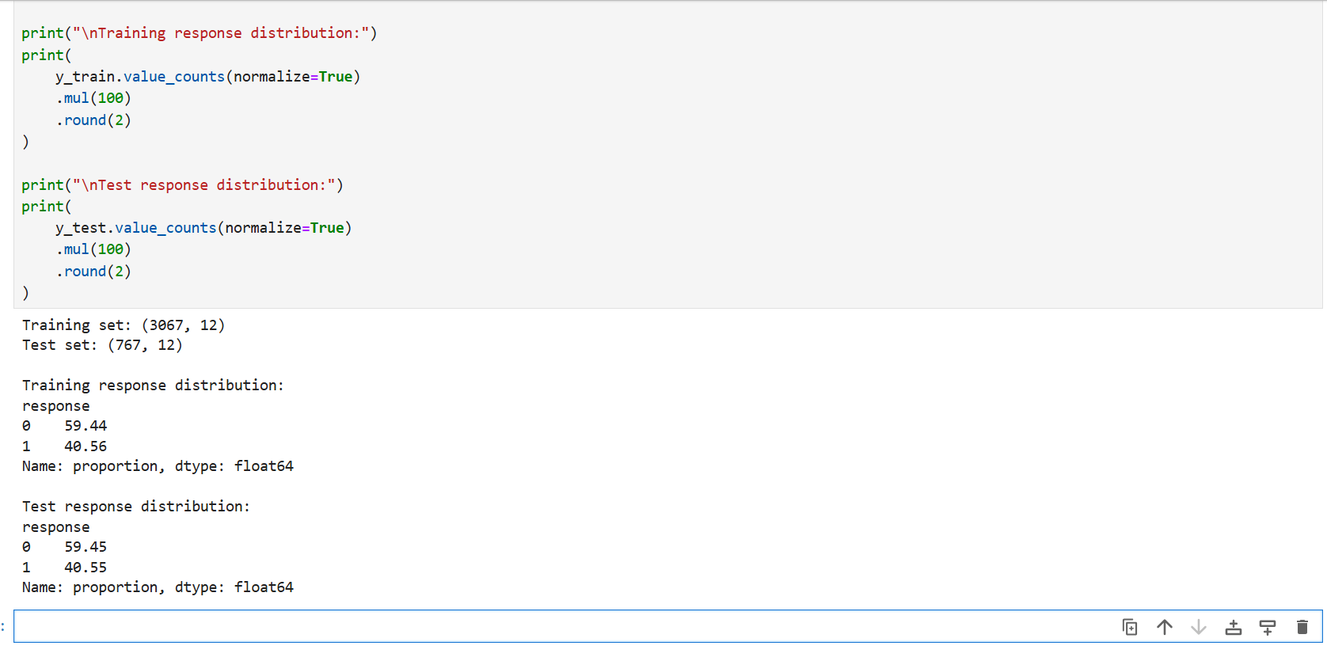
- Run Binary Logistic Regression with response as dependent variable and all others as independent variables.
Results of Binary Logistic Regression
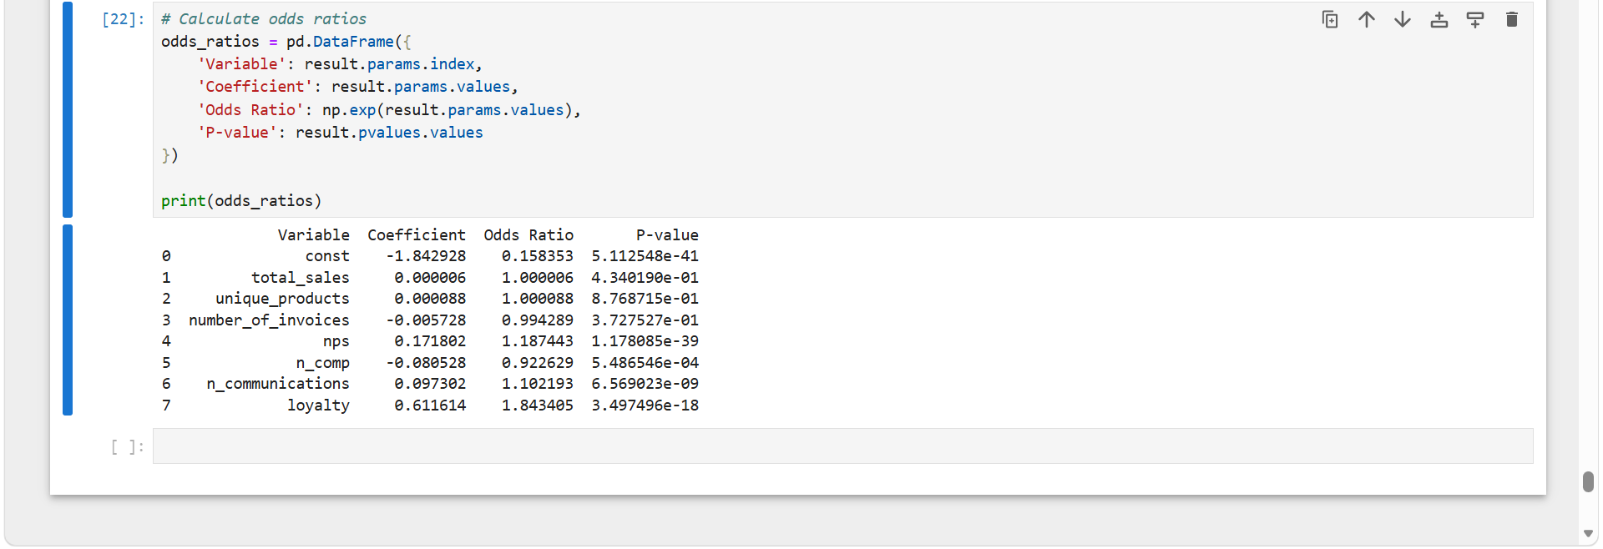
(Independent Variables: Features 1/2/3, nps,n_comp,n_communications,loyalty)

- Check which variables are significant (revise the model if needed)
The initial Binary logistic regression shows that the NPS, N_Comp, N_Communications And loyaltiy were statistically significant predictors of the Campaign response (p < 0.05). Total sales, unique products and number of invoices were not statistically significant. Therefore, the model was revised by removing the three non-significant transaction features and retaining NPS, N_Comp, N_communications and loyalty as predicators.

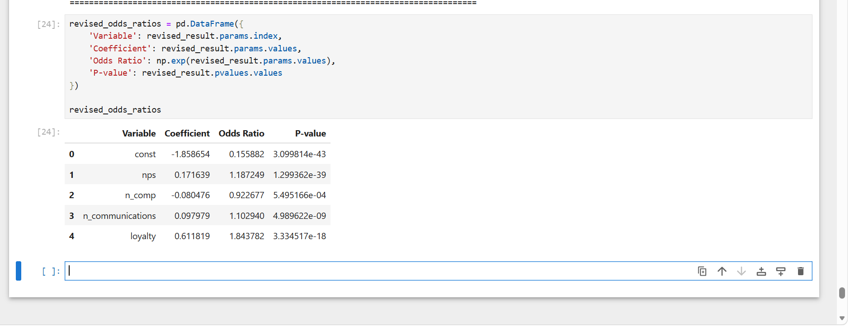

- Relate results to EDA ( do not execute any additional analysis, just compare with phase 2)
The logistic regression results largely support the patterns observed in Phase 2 EDA.
- NPS: Phase 2 showed that responders had higher NPS values. The logistic regression confirms this with a significant positive coefficient.
- n_comp: Phase 2 showed that responders had slightly fewer previous campaigns. The regression also shows a significant negative relationship.
- n_communications: Phase 2 showed that responders had slightly more communications. The regression confirms a significant positive relationship.
- Loyalty: The regression shows a significant positive relationship between loyalty and response.
- Transaction features: total_sales, unique_products, and number_of_invoices were not statistically significant in the logistic regression.
Report-ready conclusion
The Phase 3 logistic regression results are broadly consistent with the findings from Phase 2 EDA. The positive relationship between NPS and campaign response, the negative relationship between the number of previous campaigns (n_comp) and response, and the positive relationship between the number of communications and response observed during EDA were confirmed by the logistic regression model. Loyalty was also found to be a significant positive predictor of response. In contrast, total sales, number of unique products, and number of invoices were not statistically significant predictors in the regression model. Overall, the regression analysis supports the main patterns identified during the exploratory analysis while identifying which variables remain significant when considered together.

- Check multicollinearity and resolve if present

Multicollinearity was checked using the Variance Inflation Factor.
All independent variables had VIF values below 5, with the highest VIF being 2.19 for number_of_invoices.
No variables were removed from the logistic regression model based on multicollinearity.
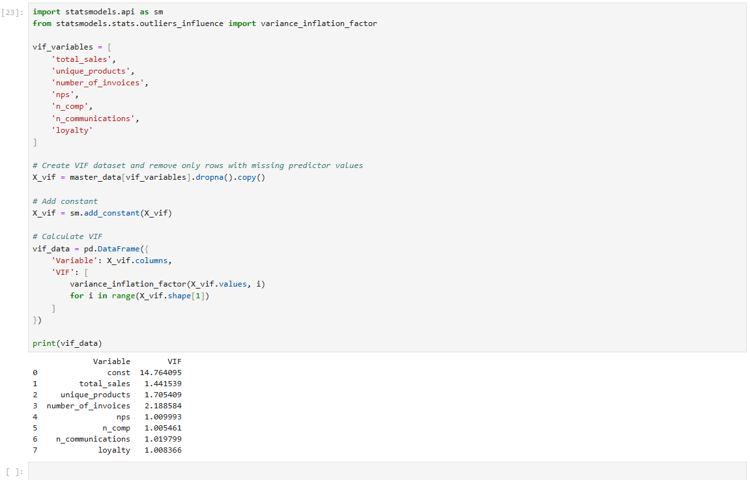

- Obtain ROC curve and AUC for train data
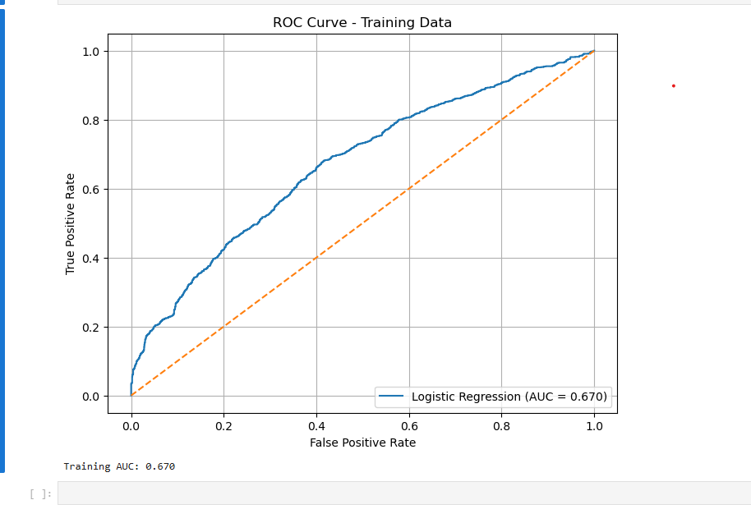
- Obtain Confusion Matrix ( Accuracy, Sensitivity, Specificity, balanced accuracy) for train data
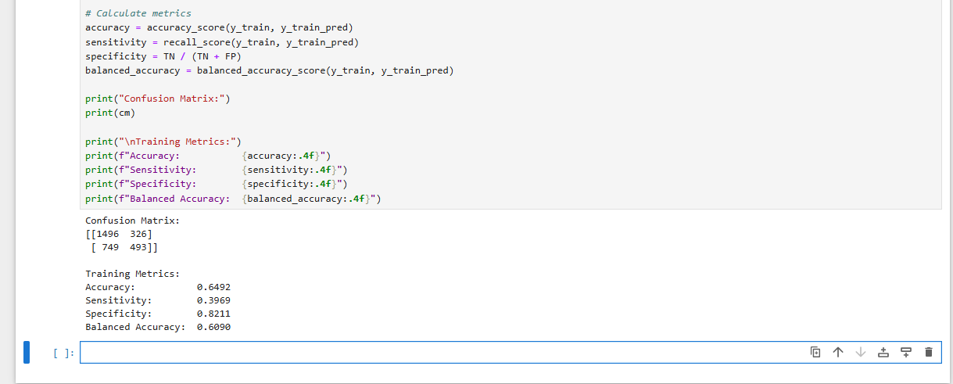

- Obtain threshold to balance sensitivity and specificity for train data
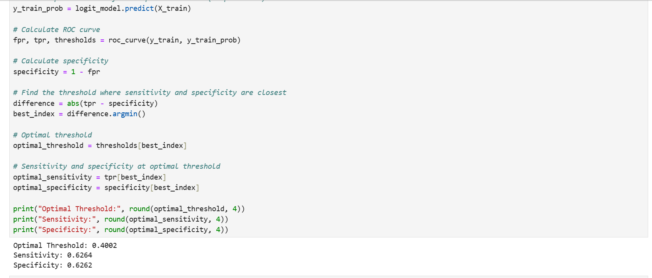
Optimal Threshold: 0.4002
Sensitivity: 0.6264
Specificity: 0.6262
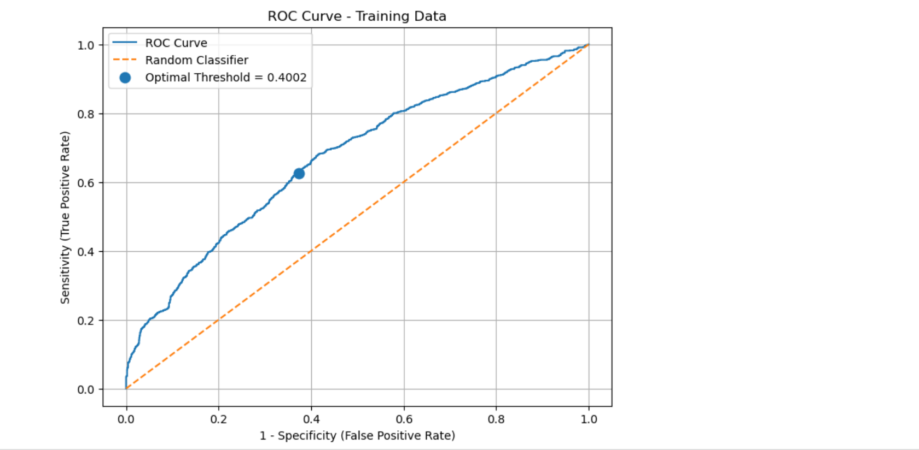

Go to step 9 only if you are satisfied with model on train data

- Obtain ROC curve and AUC for test data(compare with step 6). Do not develop a model on test data. Use predicts function.
Step 9 Test AUC: 0.6498
Step 6 Training AUC: 0.670
The test AUC is slightly lower than the training AUC, with a difference of 0.0202.
This indicates a small reduction in model performance when applied to unseen test data.
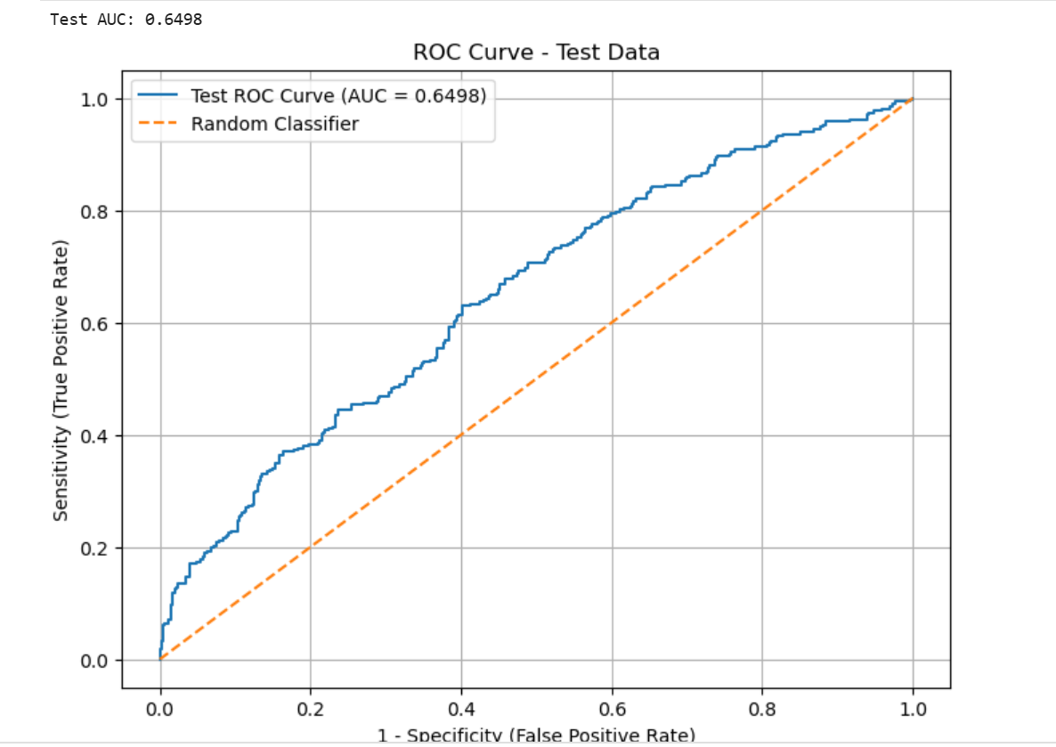

- Use above threshold to obtain sensitivity and specificity for test data(compare with step 7)
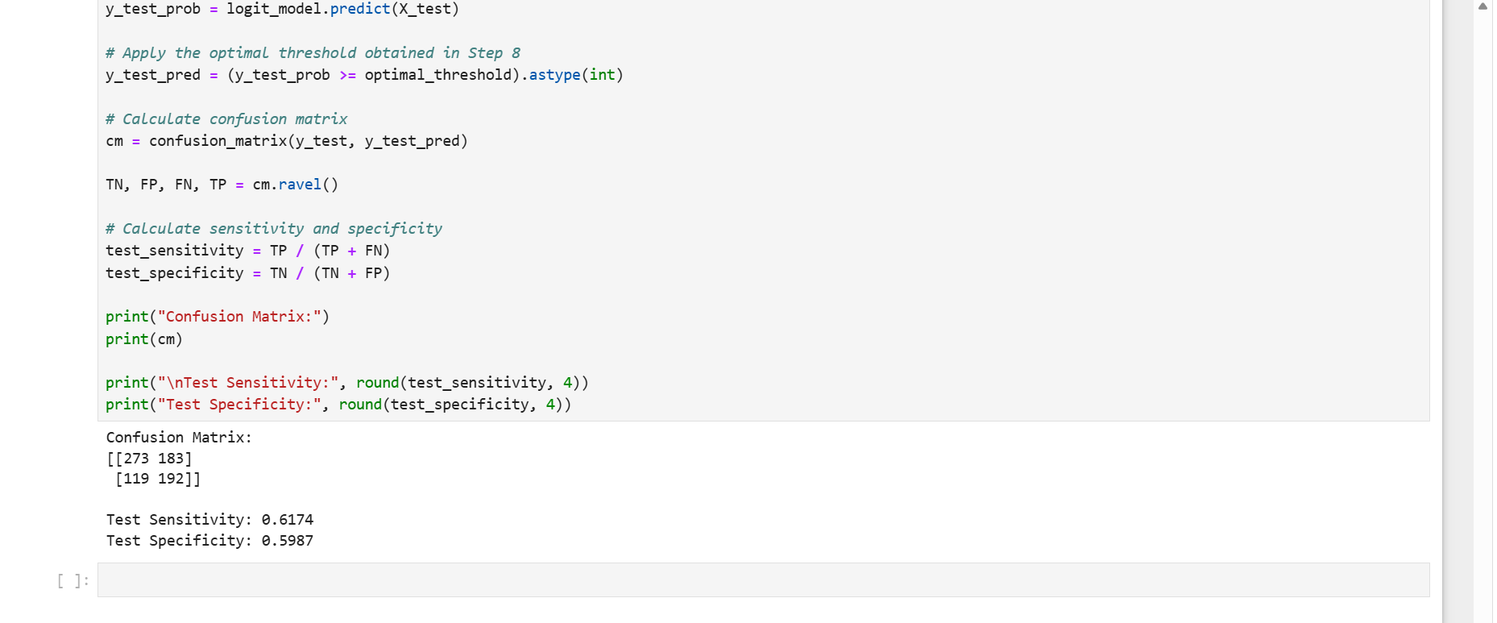

Test Results
Confusion Matrix:
[[273 183]
[119 192]]
Step 10
- Test Sensitivity: 0.6174
- Test Specificity: 0.5987
The test results indicate that the model correctly identifies approximately 61.74% of campaign responders and correctly identifies approximately 59.87% of non-responders.
Compared with Step 7
- Optimal Threshold: 0.4002
- Sensitivity: 0.6264
- Specificity: 0.6262
The test performance was lower than the training performance indicating that there is some reduction in predictive performance in unseen data.

- Try one more version using recoded variables. Finalize the model based on test data AUC (do not compare train data AUC of different models/methods)

Recoded Model Test AUC: 0.6633
Original Model AUC: 0.649
Recoded Model AUC: 0.6633
The recoded model is better because the Recorded AUC is higher than the original.
An improvement of 0.0135.
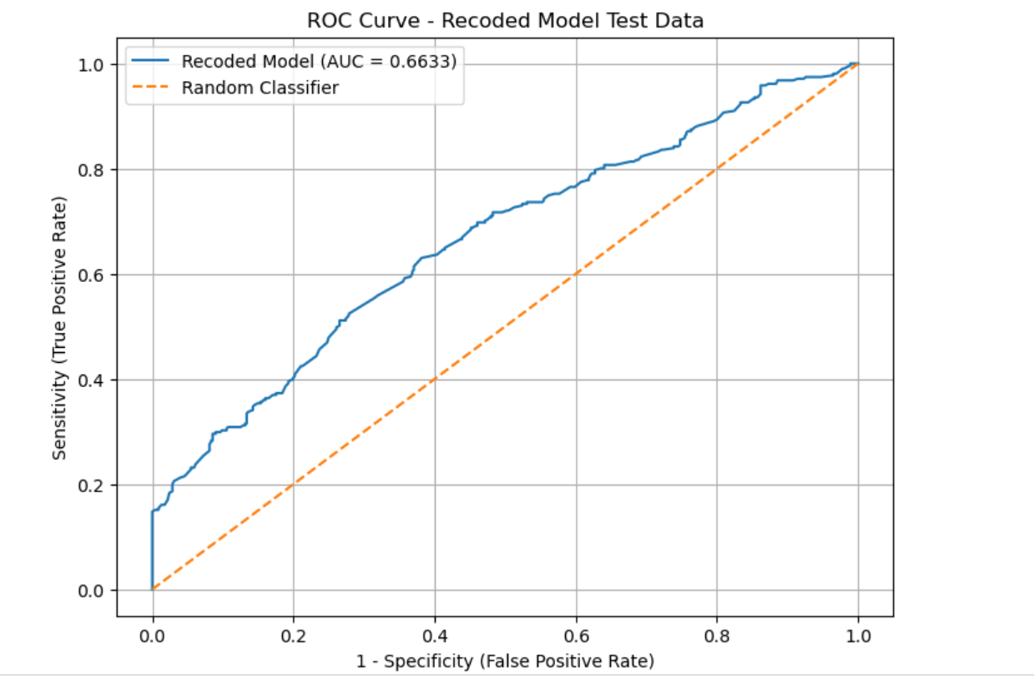

Phase 4 is about using ML methods and compare with Binary Logistic Regression

- Create data partition into train and test data sets ( 80/20)
(already done for Logistic Regression)
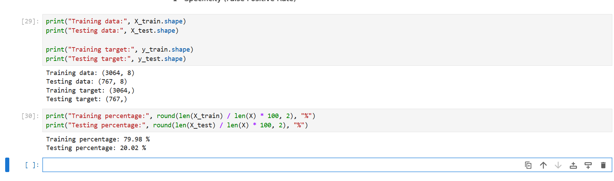
Training Data Percentage is the 79.98%
Testing Data Percentage is the 20.02%

- Apply Naïve Bayes Method on train data
response as dependent variable and all others as independent variables.
Answer:
Naïve Bayes submitted successfully using 3064 training observations and 7 independent variables

(Independent Variables: Features 1/2/3, nps,n_comp,n_communications,loyalty)

- Obtain ROC curve and AUC for train data using Naïve Bayes Method
Naïve Bayes Training AUC: 0.6714
Naïve Bayes model fitted successfully.
Training data shape: (3064, 8)
Training target shape: (3064,)
Naïve Bayes Training AUC: 0.6714

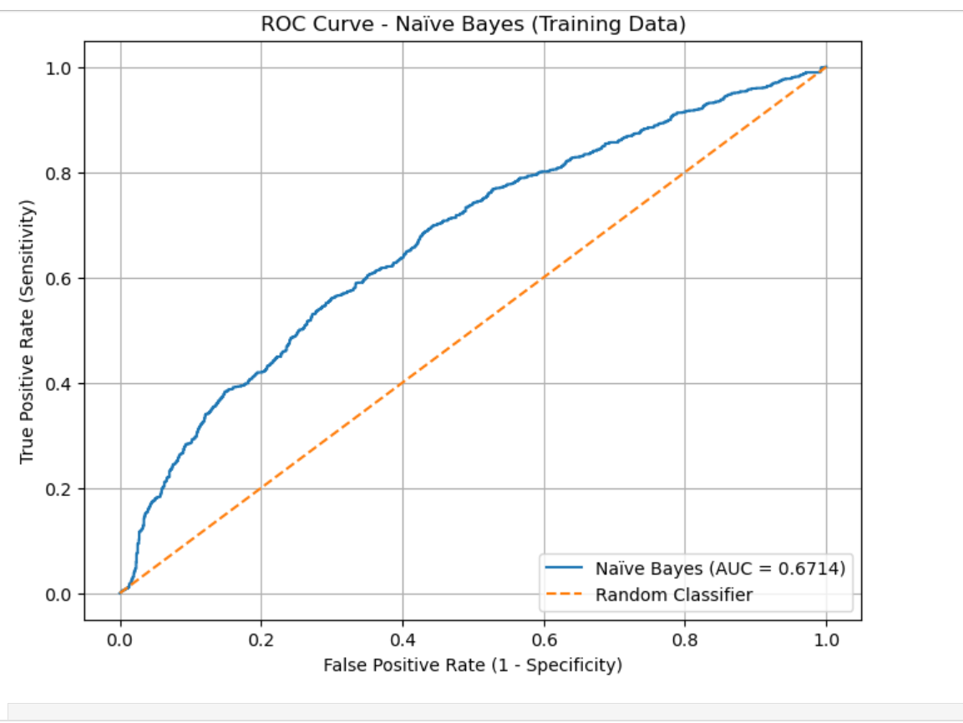
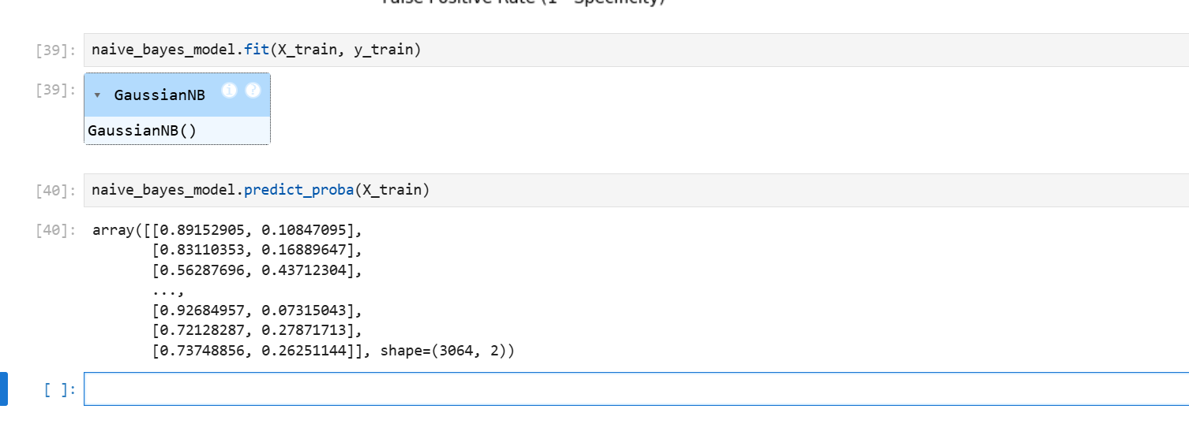

- Obtain Confusion Matrix for train data
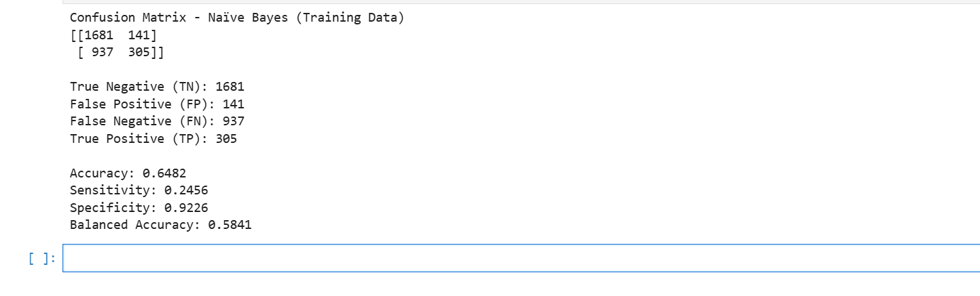

- Obtain ROC curve and AUC for test data
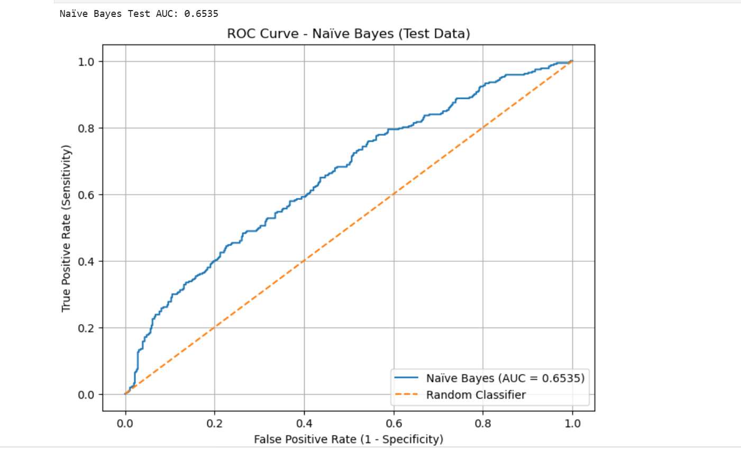

- Obtain Confusion Matrix for test data
Naïve Bayes Test AUC: 0.6535

- Repeat steps 2 to 6 using Random Forest Method, SVM, XGboost methods
- Random Forest Method,
Random Forest Training AUC: 1.0000
Confusion Matrix - Random Forest (Training Data)
[[1822 0]
[ 0 1242]]
True Negative (TN): 1822
False Positive (FP): 0
False Negative (FN): 0
True Positive (TP): 1242
Accuracy: 1.0
Sensitivity: 1.0
Specificity: 1.0
Balanced Accuracy: 1.0
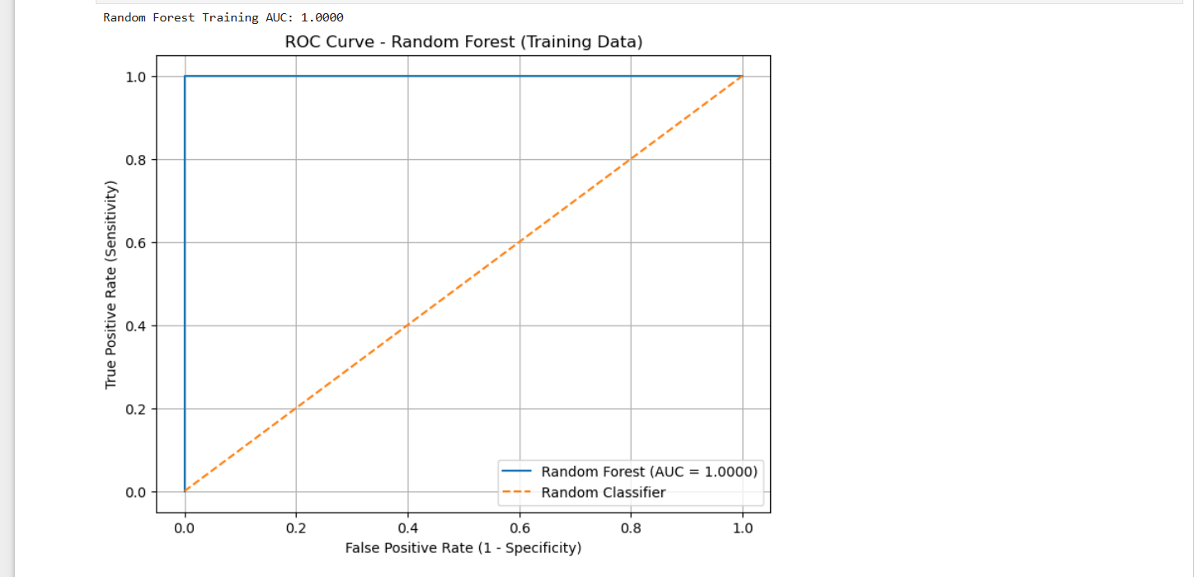

- SVM Method,
SVM Training AUC: 0.4259
Confusion Matrix - SVM (Training Data)
[[1822 0]
[1241 1]]

True Negative (TN): 1822
False Positive (FP): 0
False Negative (FN): 1241
True Positive (TP): 1

Accuracy: 0.595
Sensitivity: 0.0008
Specificity: 1.0
Balanced Accuracy: 0.5004
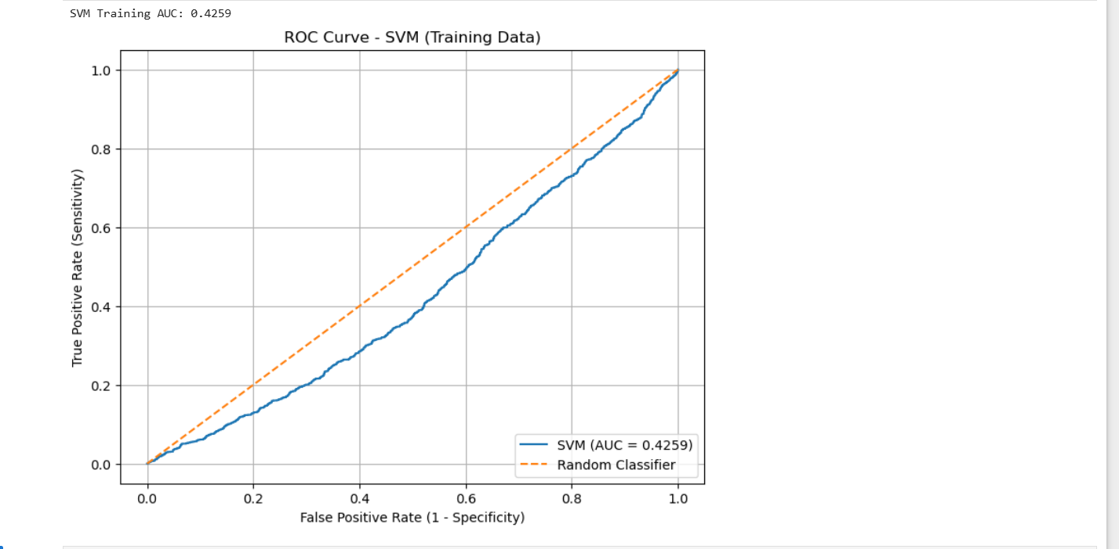

XGBoost Training AUC: 0.7933
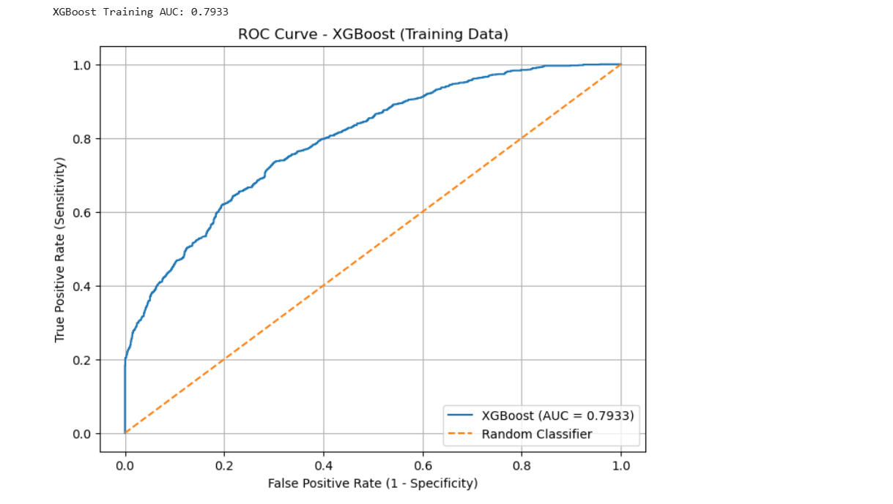

XGB Boost test data results
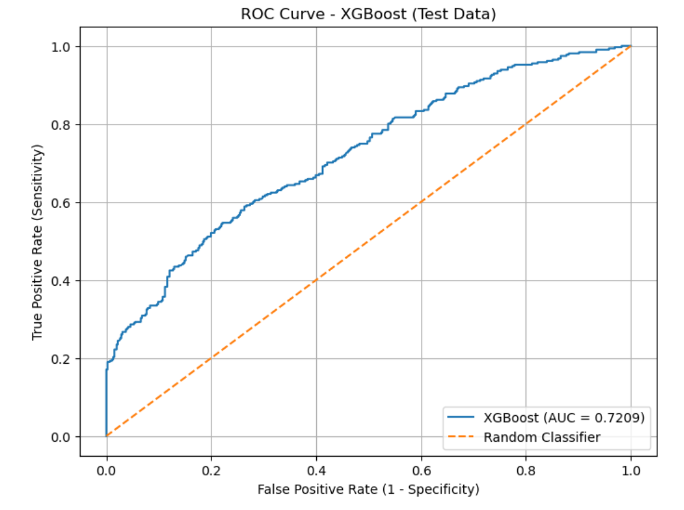
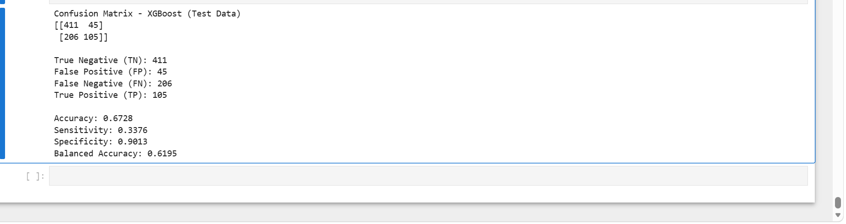

- Compare AUC for test data in case of 4 methods and finalize the method.
The best method is for which test data AUC is maximum.
AUC for 4 methods Random Forest, XGBoost, Naive Bayes, Logistic Regression
SVM
 | Rank | Method | Test AUC
0 | 1 | Random Forest | 0.782161
1 | 2 | XGBoost | 0.720934
2 | 3 | Naïve Bayes | 0.653488
3 | 4 | Logistic Regression | 0.649835
4 | 5 | SVM | 0.462825

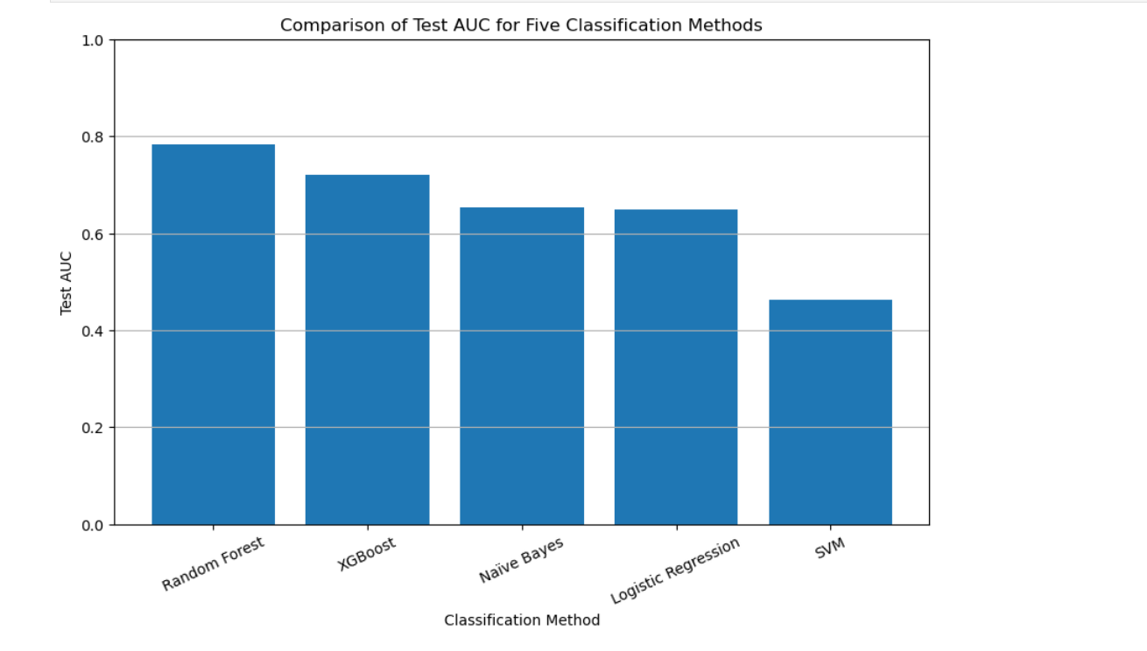

Random Forest is the highest final classification method because it achieved the highest Test AUC of 0.7822.
The Test AUC values compared to the Logistic Regression, Naive Bayes, Random Forest, SVM, and XGBoost.
Random Forest achieved the highest Test AUC of 0.7822, followed by XGBoost with 0.7209, Naive Bayes with 0.6535, Logistic Regression with 0.6498, and SVM with 0.4628.
Therefore, Random Forest was selected as the final classification method because it demonstrated the best ability to discriminate between customers who responded and those who did not respond to the campaign.
Note: You can use one of the methods of Explainable AI for ML methods.

I used Random Forest with its highest AUC 0.7822 and used SHAP.
Explainable AI was applied to the final Random Forest model using SHAP (Shapley Additive exPlanations).
The results show that the NPS was the most influential predictor of campaign response with a mean absolute SHAP value of 0.076339.
Feature | Mean Absolute SHAP
0 | nps | 0.076339
1 | loyalty | 0.050185
2 | n_communications | 0.046280
3 | n_comp | 0.025586
4 | average_invoice_value | 0.014522
5 | CustomerID | 0.013992
6 | unique_products | 0.012943
7 | average_quantity_per_invoice | 0.012876
8 | total_sales | 0.011569
9 | average_product_price | 0.011295
10 | customer_activity_days | 0.008540
11 | purchase_days | 0.006460
12 | number_of_invoices | 0.005525

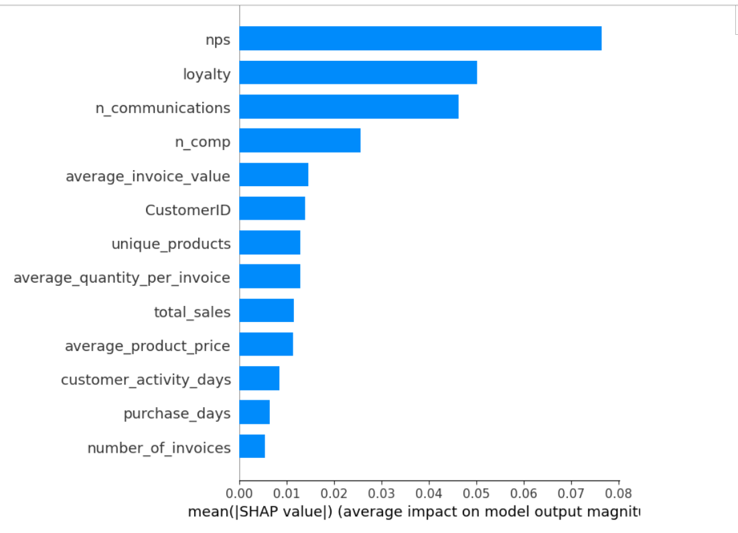

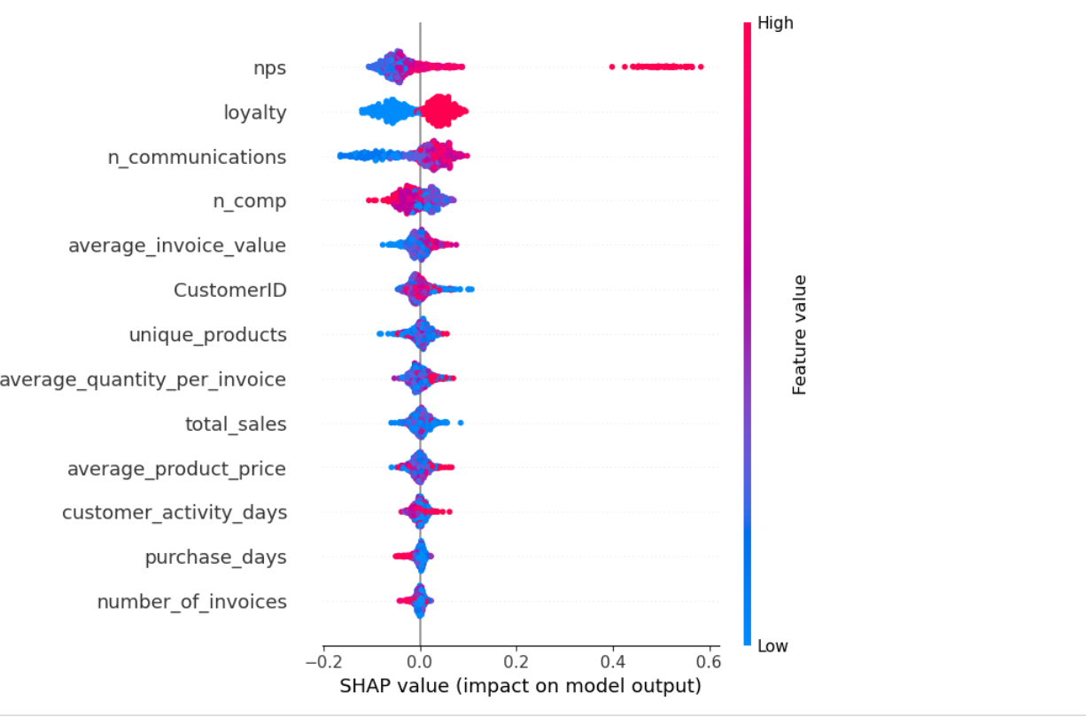

Note: You can use one of the methods of Explainable AI for ML methods.

***************************************************************

